**Tuberculosis and other Mycobacterial Infections**

* Tuberculosis (TB) commonly defined as a chronic, debilitating disease, TB occasionally assumes an acute, rapidly progressive course.
* The disease affects practically all species of vertebrates.
* The widespread occurrence of multidrug-resistant (MDR) strains and extensively drug-resistant (XDR) strains of *M tuberculosis* is of concern to clinicians and public health and regulatory officials involved in the control of disease.
* Bovine TB is still a significant zoonosis in nonindustrialized countries of the world.
* Signs and lesions are generally similar in the various species.

**Etiology:**

* The main types of *M tuberculosis* complex (mammalian tubercle bacilli) recognized are *M tuberculosis*, *M canettii*, *M bovis*, *M caprae*, *M pinnipedii*, *M microti*, *M mungi*, and *M africanum*.
* The *M avium* complex includes *M avium avium* (avian tubercle bacilli), *M avium hominissuis* (isolated from people, swine, and other mammals), and *M intracellulare*. The types differ in cultural characteristics and pathogenicity.
* Several serovars of *M avium avium* are recognized; however, only serovars 1, 2, and 3 are pathogenic for birds. *M bovis* may survive on pasture for ≥2 mo, and *M avium* may survive in soil for ≥4 yr.

**Pathogenesis:**

* Inhalation of infected droplets expelled from the lungs is the usual route of TB infection, although ingestion, particularly via contaminated milk or water, also occurs. Intrauterine and coital methods of infection are recognized less commonly.
* Inhaled bacilli are phagocytosed by alveolar macrophages that may either clear the infection or allow the mycobacteria to proliferate. In the latter instance, a primary focus may form, mediated by cytokines associated with a hypersensitivity reaction that consists of dead and degenerate macrophages surrounded by epithelioid cells, granulocytes, lymphocytes, and later, multinucleated giant cells.
* The purulent to caseous, necrotic center may calcify, and the lesion may become surrounded by granulation tissue and a fibrous capsule to form the classic “tubercle.”
* The primary focus plus similar lesions formed in the regional lymph node is known as the “primary complex.”
* In alimentary forms of disease, the primary focus may be found in the pharynx or mesenteric lymph nodes or, less commonly, in the tonsils or intestines.
* The cellular composition of and presence of acid-fast bacilli in tuberculous lesions differ between and within host species.
* The primary complex seldom heals in animals and may progress slowly or rapidly.
* Dissemination through vascular and lymphatic channels may be generalized and rapidly fatal, as in acute miliary TB.
* Nodular lesions may form in many organs, including the pleura, peritoneum, liver, kidney, spleen, skeleton, mammary glands, reproductive tract, and CNS.
* A prolonged, chronic course may also ensue, with lesions usually having a more localized pattern of distribution.

**Clinical Findings:**

[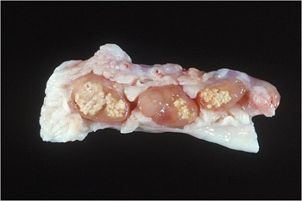](http://www.msdvetmanual.com/generalized-conditions/tuberculosis-and-other-mycobacterial-infections/overview-of-tuberculosis-and-other-mycobacterial-infections)

Gross lesions,   Mycobacterium avium  , lymph node, pig

[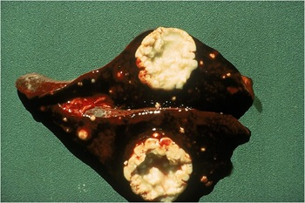](http://www.msdvetmanual.com/generalized-conditions/tuberculosis-and-other-mycobacterial-infections/overview-of-tuberculosis-and-other-mycobacterial-infections)

Tuberculous lesions, liver, nonhuman primate

[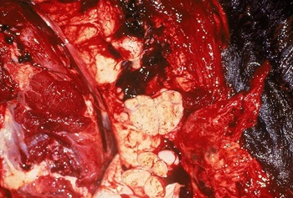](http://www.msdvetmanual.com/generalized-conditions/tuberculosis-and-other-mycobacterial-infections/overview-of-tuberculosis-and-other-mycobacterial-infections)

Mycobacterium bovis   lesions, infected bovid

[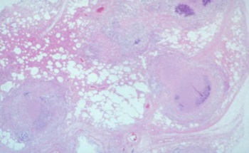](http://www.msdvetmanual.com/generalized-conditions/tuberculosis-and-other-mycobacterial-infections/overview-of-tuberculosis-and-other-mycobacterial-infections)

Mycobacterium bovis   granuloma, elk, histopathology

* The clinical signs of TB reflect the extent and location of lesions.
* Generalized signs include progressive emaciation, lethargy, weakness, anorexia, and a low-grade, fluctuating fever.
* The bronchopneumonia of the respiratory form of the disease causes a chronic, intermittent, moist cough with later signs of dyspnea and tachypnea.
* The destructive lesions of the granulomatous bronchopneumonia may be detected on auscultation and percussion.
* Superficial lymph node enlargement may be a useful diagnostic sign when present.
* Affected deeper lymph nodes cannot always be palpated, but they may cause obstruction of the airways, pharynx, and gut, leading to dyspnea and ruminal tympany.

**Diagnosis:**

* The single most important diagnostic test for TB is the intradermal tuberculin test.
* Necropsy findings of the classic “tuberculous” granulomas are often very suggestive of the disease.
* Confirmation of diagnosis is by isolation and identification of the organism, with culture usually taking 4–8 wk, or by PCR, which requires only a few days.
* Molecular techniques, such as restriction fragment length polymorphism (RFLP) or variable number tandem repeat (VNTR) provide definitive information useful in conducting epidemiologic investigations.

**Control:**

* The main reservoir of *M bovis* infection is cattle. However, other animals have been found to be reservoirs in some countries, including badgers and red deer (England, Ireland); red deer, possums, and ferrets (New Zealand); mule deer, white-tailed deer, elk, and American bison (North America); African buffalo (South Africa); and water buffalo (Australia).
* The prevalence of disease in such reservoirs influences the incidence of disease in other species. Carnivores and scavengers can acquire *M bovis* by consumption of infected carcasses. These species include lion, coyote, wolf, hyena, cheetah, black bear, bobcat, and leopard. Warthogs, ferrets, raccoon, European wild boar, opossums, and feral pigs have also been found to be infected with *M bovis*.
* The three principal approaches to the control of TB are test and slaughter, test and segregation, and chemotherapy.

1. The test and slaughter policy is the only one assured of eradicating TB and relies on the slaughter of reactors to the tuberculin test. In an affected herd, testing every 2 mo is recommended to rid the herd of individuals that can disseminate infection.
2. Routine hygienic measures aimed at cleaning and disinfecting contaminated food, water troughs, etc, are also useful. Test and slaughter has been used widely in the UK, USA, Canada, Germany, New Zealand, and Australia. In some European countries, where test and slaughter would have been impractical, varying forms of test and segregation have been used, with test and slaughter used only in the final stages of eradication.
3. The BCG (bacille Calmette-Guérin) vaccine, sometimes used to control TB in people, has proved to provide little protection against virulent *M bovis* in most animal species, and inoculation often provokes a severe local granulomatous reaction. Moreover, BCG-vaccinated animals usually respond on the tuberculin skin test.